NRE/Forest Service Briefing Paper

April 7, 2022
______________________________________________________________________________
Topic: Executive Summary, Wildfire Crisis Strategy, Initial Landscape Investment Recommendations
From: Brian Ferebee, Chief Executive of Intergovernmental Relations, 720-646-1995, brian.ferebee@usda.gov

Introduction
In November 2021, the U.S. Department of Agriculture Forest Service initiated a process to identify landscapes where investments of the Bipartisan Infrastructure Law (BIL) and other funding could reduce exposure of communities and infrastructure to the risk of catastrophic wildfire.
A small number of firesheds currently present the largest risk to communities, based on historic fire behavior. These high-exposure firesheds were identified as critical anchoring geographies around which Initial Landscape Investments will be built.
The Forest Service initiated the selection process with a call to regional leadership to engage with other Federal agencies, Tribes, States, and other partners in identifying high-risk landscapes. As outlined in the Wildfire Crisis Strategy Implementation Plan, the goal of this initial selection process was to identify landscapes that (1) have projects that are at scale or can be built out to scale, (2) are outcome driven, (3) are collaboratively developed with communities and ready for implementation, (4) allow for investment in underserved communities, (5) could leverage current partner investments, and (6) could maximize use of existing authorities.
In total, 29 candidate Initial Landscape Investments were proposed. These high-risk firesheds were identified as critical anchoring geographies around which Initial Landscape Investments will be built.

Recommendation
The following list represents those landscapes that are most closely aligned with high-risk firesheds and provide treatments at a scale or can be built out to scale that will make a difference in reducing wildfire risk. This initial announcement is a total of 10 landscapes in Arizona, California, Colorado, Idaho, Montana, New Mexico, Oregon, and Washington. In FY 2022, the agency intends to invest $131 million for implementation within high-risk firesheds, as well as investing in enabling conditions that will lead to increased capacity over time (including $34 million in salary). These investments will lead to 208,000 acres of treatment in FY 2022, but more importantly, will lead to increased outcomes in subsequent years.

 |  |  | FY22 |  | Total for FY22-24
Landscape Name | State | Size of Landscape (Acres) | FY22 Funding (Millions) | FY22 Accomplishment (Acres/mmbf) | Total FY22-24 Funding (Millions) | Total FY22-24 Accomplishment (Acres)
4FRI | AZ | 2,400,000 | $12.0 | 100,000/139 | $160.0 | 300,000
Prescott | AZ | 401,000 | $11.1 | 28,000/2 | $28.7 | 87,700
North Yuba | CA | 356,000 | $6.8 | 4,500/12 | $25.5 | 16,900
Stanislaus | CA | 245,000 | $21.8 | 8,500/14 | $55.2 | 32,500
Colorado Front Range | CO | 3,500,000 | $18.1 | 10,000/7 | $170.4 | 36,100
Southwest Idaho | ID | 1,720,000 | $17.4 | 18,000/41 | $59.5 | 55,000
Kootenai Complex | MT | 800,000 | $3.6 | 900/47 | $19.3 | 7,200
Enchanted Circle | NM | 1,500,000 | $6.6 | 9,000/1 | $11.3 | 32,500
Central Oregon | OR | 2,600,000 | $4.5 | 5,000/- | $43.1 | 50,000
Central Washington Initiative | WA | 2,500,000 | $24.6 | 24,000/- | $102.6 | 124,000
 |  | Total | $131.3 | 208,000/263 | $671.0 | 742,000

Table 1. Proposed Initial Landscape Investments. NOTE: Acreage denotes the size of the landscape, not actual acres to be treated within that landscape.

This summary table represents total size of landscapes, FY22 funding and planned accomplishments as well as total funding and accomplishments for FY22-24. The landscape size does not represent acres to be treated. Strategic treatment objectives focused on reducing approximately 80% of the exposure to structures indicate the need to treat 20-40% of the overall Fireshed. The overall size of these 10 landscapes is 16 million acres, of which 7 million acres are high-risk firesheds. Applying the 20-40% treatment objective would indicate the long term need to treat 1.4 to 2.8 million acres on these landscapes.

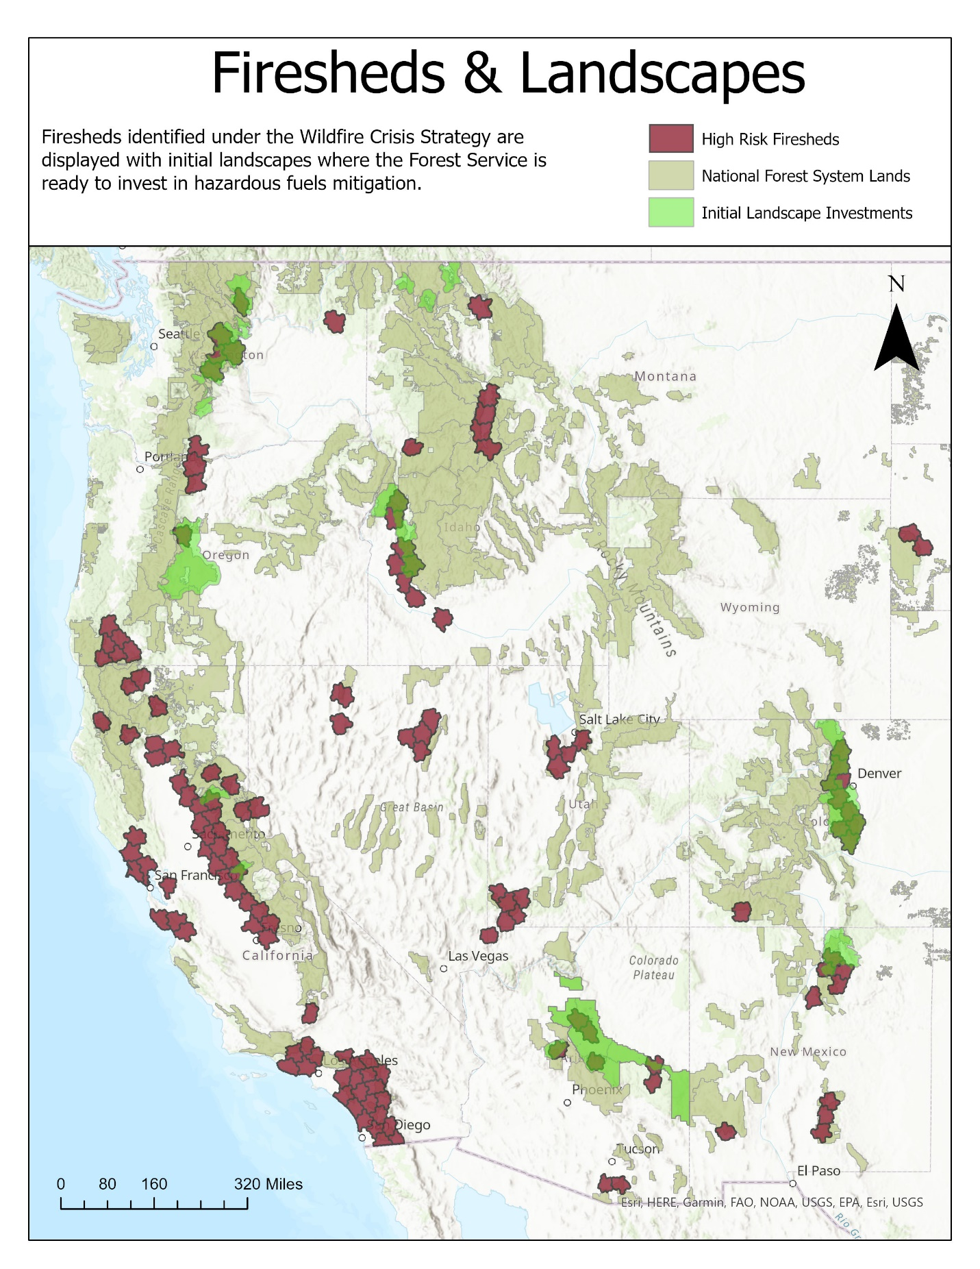

Other Influences and Factors
Though the selection of initial landscape investments was informed by the goals listed in the introduction above, the agency did perform some preliminary analyses to determine alignment with current administrative priorities and interest areas. We recognize that reducing risk can be translated by not only a reduction in fuels, but reduced impacts to critical watersheds, socially vulnerable communities, and carbon stocks.
Overlap With Critical Watersheds
Stand-replacing events can have significant postfire impacts to source water supplies over time. Healthy vegetation in forested headwaters is critical to potable water quality and quantity, as denuded landscapes can expedite sedimentation and ash deposits into reservoirs as well as decrease filtration capacity essential for recharge. The agency has characterized potential wildfire exposure to public source watersheds using national Environmental Protection Agency source water protection area data to identify where public water systems may be most vulnerable.

Social Vulnerability Connections
The Forest Service also conducted a preliminary and rapid analysis of social vulnerability associated with the ten selected landscapes using the Center for Disease Control’s Social Vulnerability Index (SVI).
Several factors, including poverty, lack of access to transportation, and crowded housing may weaken a community’s ability to prevent human suffering and financial loss in a disaster. These factors are known as social vulnerability and are what the SVI index measures.
For this analysis, the agency examined the vulnerability of populations at the county-level within each of the initial landscapes proposed for FY 2022 BIL funding under the Wildfire Crisis Strategy. The exercise is an initial effort to demonstrate how demographic information might be used to promote equity considerations in future decisions processes and management activities and will be used to inform opportunities as a part of the implementation of FY 2022 investments.

Carbon Sequestration
Forest carbon implications of contemporary fuels management treatments are complex and the subject of ongoing research. What best available science indicates is that carbon stocks of both live and dead biomass on the landscape are out of balance, undermining long-term ecosystem health and carbon stocks. Across the West, interactions between drought and temperature increases, insect and disease-killed trees, and fuels buildup from a century of fire exclusion are driving patterns of heightened wildfire incidence and severity. Investments in large-scale interventions to remove the excess fuels implies a near-term carbon loss in favor of fostering a more resilient landscape in the long term. This near-term loss can be mitigated by transforming fuels into harvested wood products, including innovative uses such as biochar that store carbon over long periods. A lack of intervention will likely serve to maintain carbon stocks in the near term but give way to greater net emissions and loss of ecosystem services in the long term, given the persistent patterns of wildfire, drought, and climate change.
Partner Connections to Landscapes
Each landscape is dependent on a place-based network of partners who have come together united in a common goal to work together on the landscape. Achieving the desired pace and scale of land treatments on these landscapes will require the support of State and local governments, Tribes, nongovernment organizations, and private contractors. Many of these initial landscapes already have momentum in leveraging resources across boundaries. Once landscapes are announced, work will begin in earnest to develop long-term, leveraged funding plans on these landscapes.

Koch, Frank H.; Ellenwood, James R. 2020. Sustainable Forest Indicator 3.16. https://www.fs.fed.us/research/sustain/criteria-indicators/

